TELECOM CUSTOMER DATASET
About Dataset
Dataset Overview
- This dataset contains detailed information about telecom customers in the United States, including their demographic details, subscription plans, and churn status. The data has been collected to help identify the key factors contributing to customer churn, which occurs when customers cancel their services.
Key Attributes
- Customer Demographics: Includes gender, city, state, zip code, and geographic coordinates (latitude and longitude).
- Subscription Information: This includes details about the customer's contract type (month-to-month, one-year, two-year), payment method (electronic check, mailed check, credit card, etc.), and monthly charges.
- Churn Data: Indicates whether the customer has churned (Yes/No), along with a score predicting their likelihood to churn, reasons for leaving, and the customer lifetime value (CLTV).
- Churn Reasons: Specific reasons for churn are included, such as competitors offering better deals, service dissatisfaction, or moving to a new location.
Key Columns
- CustomerID: Unique identifier for each customer.
- Gender: Gender of the customer.
- Contract: The contract type (Month-to-month, One year, etc.).
- Payment Method: How the customer makes payments (e.g., Bank transfer, Credit card).
- Monthly Charges: The amount the customer is billed monthly.
- Total Charges: Cumulative amount billed to the customer.
- Churn Label: Indicates whether the customer has churned (Yes/No).
- Churn Reason: Reason why the customer churned.
Dataset Uses
This dataset can be used for various machine learning tasks, including:
- Customer Churn Prediction: Identify patterns in customer behaviour that signal their likelihood of churning.
- Customer Segmentation: Group customers based on their demographics, subscription plans, or payment behaviour.
- Churn Reason Analysis: Understand the main reasons customers are leaving and build strategies to reduce churn.

Dataset Highlights
- 33 features capturing various aspects of customer demographics, payment behavior, and churn data.
- Rich churn data with reasons for churn, which can help develop insights into customer retention strategies.
- Geospatial information including customer locations (latitude, longitude) which can be useful for regional analysis of churn.

PROBLEM STATEMENT
Build a Machine Learning model to predict whether a telecom customer will churn (Yes/No) based on their demographic details, subscription information, and payment behavior.

BUSINESS PROBLEM
Telecom companies lose revenue when customers churn.
Goal:
- Identify high-risk customers
- Reduce churn through targeted retention strategies
- Improve Customer Lifetime Value (CLTV)

Define Modeling Objective
This is a:
✅ Binary Classification Problem
Because:
- Output = Yes or No

Data Cleaning:
Removed unnecessary data
Handled missing data
Replaced null data and space
Created categories to simplify the data for representation
Created groups
Standardize categorical values

EDA Analysis
Created churn
Checked target distribution
If churn is 25% and non-churn 75% → Imbalanced dataset.
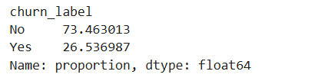
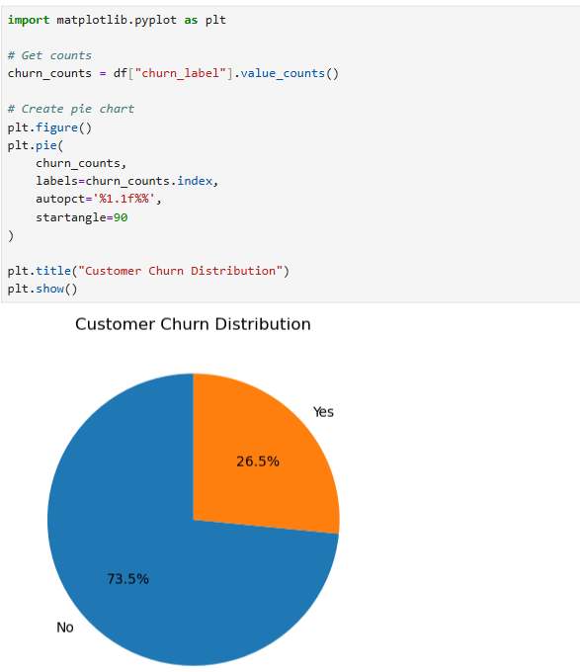
churn level is low so we can create a model

CHURN BY CONTRACT TYPE

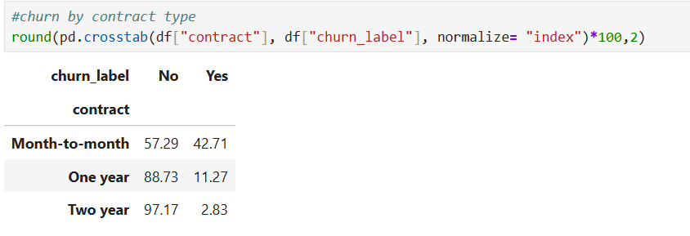
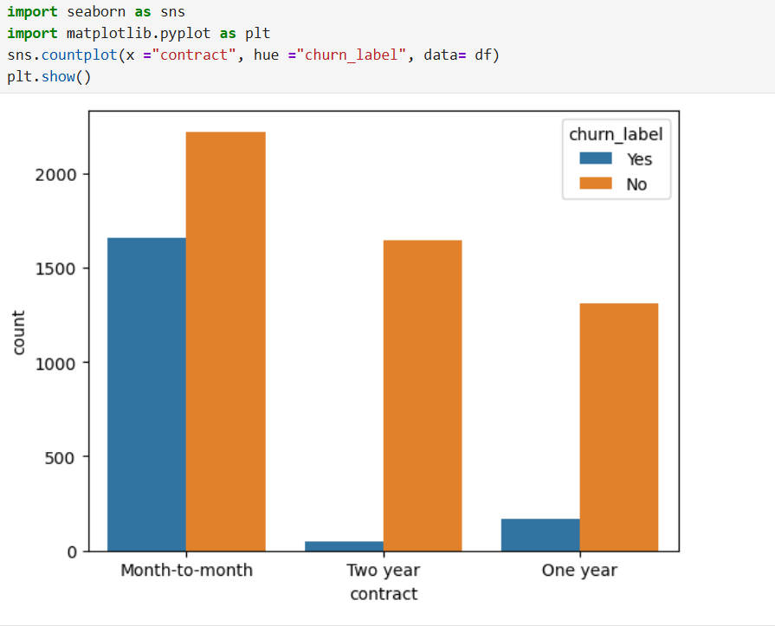
CHURN BY PAYMENT METHOD
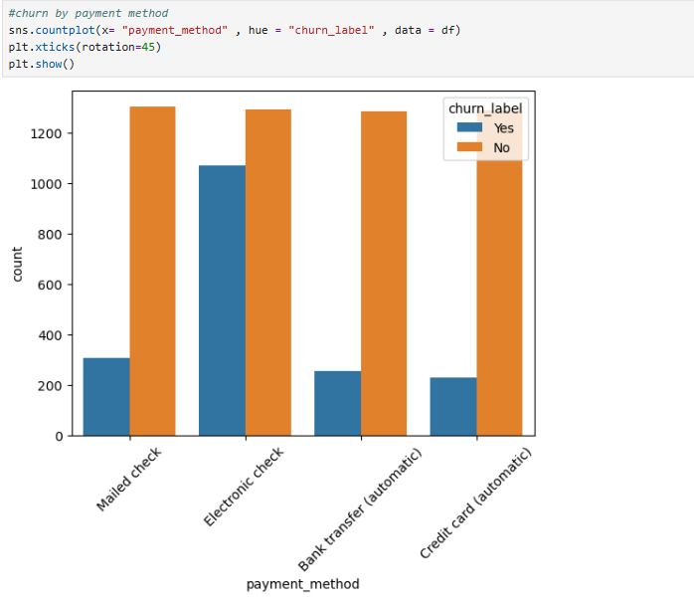

CHURN BY GENDER
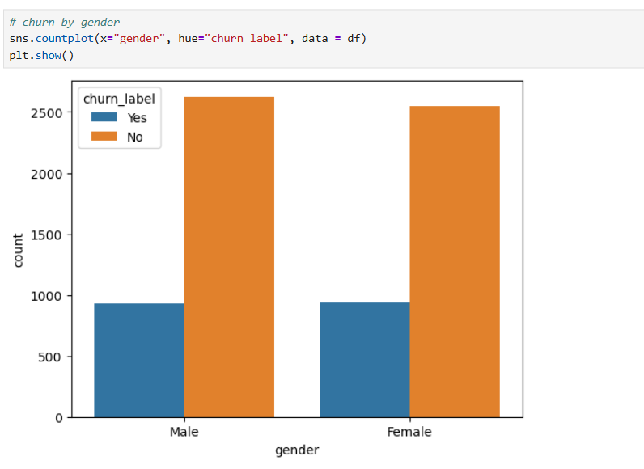

TOP CHURN REASONS
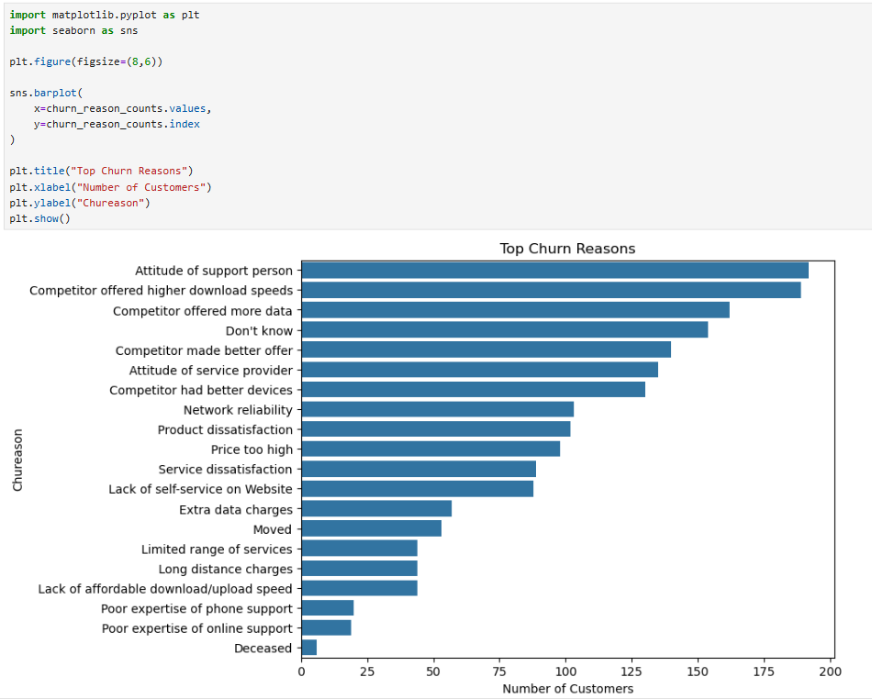

ANALYZE NUMERIC VARIABLE
Monthly charges vs churn
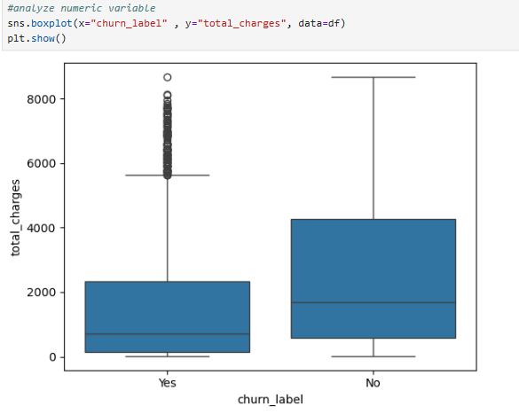
Total_charges vs churn
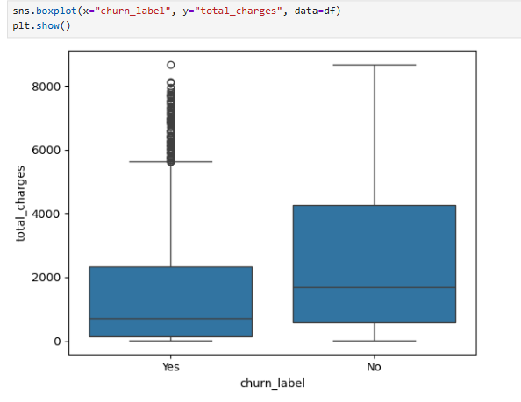

Tenure vs churn
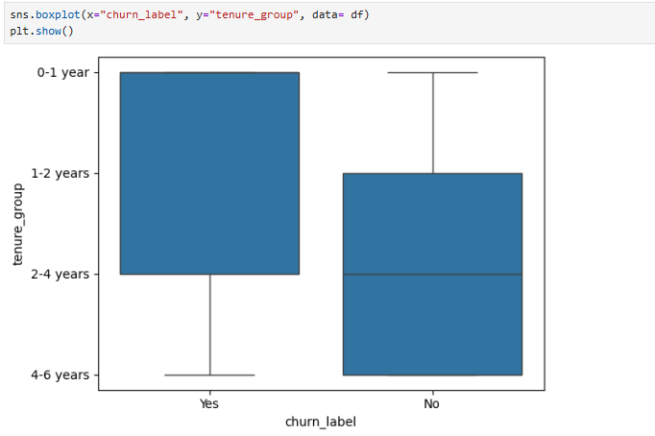

Correlation analysis
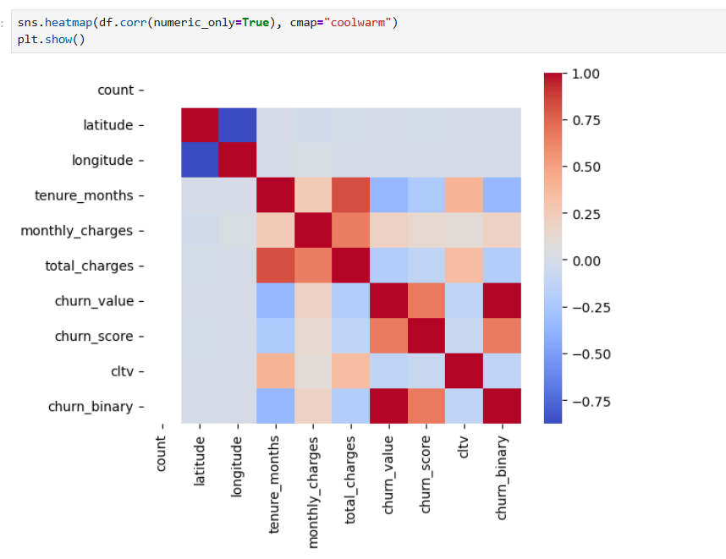

- Month-to-month customers have 40% churn rate
- Customers with high monthly charges churn more
- Low tenure customers are high risk
- Electronic check users show higher churn

FEATURE ENGINEERING
We will:
1️⃣ Remove unnecessary columns
2️⃣ Handle missing values
3️⃣ Convert target variable
4️⃣ Create new useful features
5️⃣ Encode categorical variables

TRAIN TEST SPLIT

Logistic regression model
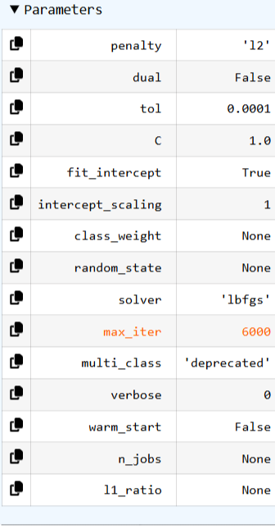

Logistic regression
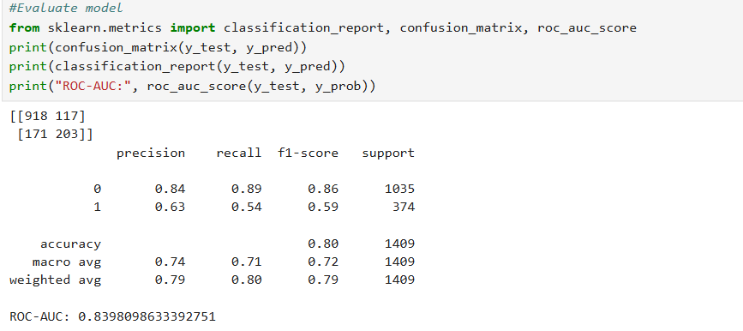
Meaning:
- 918 → Correctly predicted Non-Churn
- 117 → False positives (predicted churn but didn’t)
- 171 → Missed churn customers ❗
- 203 → Correctly predicted churn

Random forest model
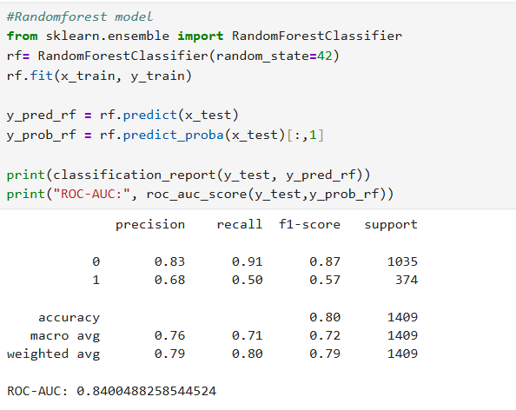

Comparison Between Models
Metric | Logistic | Random Forest
Accuracy | 80% | 80%
ROC-AUC | 0.839 | 0.840
Churn Recall | 0.54 | 0.50
Churn Precision | 0.63 | 0.68

Interpretation
- Model predicts non-churn very well.
- Recall for churn = 54% → It catches about half of churn customers.
- ROC-AUC 0.83 → Good discrimination power.

CONCLUSION
- Both models perform almost the same.
- Logistic catches slightly more churn customers.
- Random Forest is slightly more precise.
- ROC-AUC is nearly identical.

